STUDENT PERFORMANCE ANALYTICS DASHBOARD

A Project Report Submitted in the partial fulfillment of the requirements for the award of the degree of

BACHELOR OF TECHNOLOGY
In

DEPARTMENT OF CSE
By
A. Srija – 2420030062
I. Srivalli – 2420030742

Under the Esteemed Guidance of

Dr. N Sunanda

Associate Professor

Department of Computer Science and Engineering

AY- 2026–2027

Semester: Odd semester




K L (Deemed to be) University
DEPARTMENT OF CSE

Declaration

We hereby declare that the project report entitled “Student Performance Analytics Dashboard” is a record of work carried out by A. Srija (2420030062) and I. Srivalli (2420030742), in partial fulfillment of the requirements for the award of the degree of Bachelor of Technology at K L (Deemed to be) University.
We declare that the content presented in this report is prepared for this project and that all external sources used have been acknowledged in the References section.

K L (Deemed to be) University
DEPARTMENT OF CSE

CERTIFICATE

This is to certify that the project report entitled “Student Performance Analytics Dashboard” is a bonafide work carried out by A. Srija (2420030062) and I. Srivalli (2420030742), in partial fulfillment of the requirements for the award of the degree of Bachelor of Technology in Computer Science and Engineering at K L (Deemed to be) University during the academic year 2026–2027.

_____________________  Signature of the Guide  Dr. N. Sunanda  Associate Professor, CSE | _____________________  Course Coordinator  Dr. N. Sunanda  Department of CSE | _____________________  Head of the Department  Dr.P. Venkateswara Rao  Department of CSE

ACKNOWLEDGEMENT
We express our sincere gratitude to the university and the Department of Computer Science and Engineering for providing the opportunity and facilities to work on this project.
We thank our course coordinator and project guide, Dr.N.sunanda, for their guidance, suggestions and support throughout the project. We also thank the faculty members, classmates and everyone who directly or indirectly supported us in completing this work.
Finally, we express our gratitude to our parents and family members for their encouragement and support.

A. Srija – 2420030062
I. Srivalli – 2420030742

Abstract
Student Performance Analytics Dashboard is a Data Science project designed to analyze student-related information and present the results in an easy-to-understand visual form. Student performance can be associated with several factors, including marks, attendance, study time, absences and previous grades. Examining a large amount of such data manually can be difficult and time-consuming.
The proposed system follows a sequence of data collection, data cleaning, data analysis and visualization. Python is used for data processing. Pandas and NumPy support data handling and numerical operations, while Matplotlib and Seaborn are used to create visualizations. Streamlit is proposed as the framework for presenting the analysis through an interactive dashboard.
The dashboard is intended to display useful information such as average marks, attendance analysis, study-hour analysis, grade distribution and relationships between selected variables. The project aims to help educators understand performance patterns and support data-informed academic decisions. The current project focus is analytics and visualization; machine-learning-based score prediction is considered an optional future enhancement.

Index
Chapters | Title | Contents
1 | Introduction | Background, problem statement, scope, objectives, importance and target users
2 | System Requirements | Hardware, software and development tools
3 | Technology Stack | Python, Pandas, NumPy, Matplotlib, Seaborn and Streamlit
4 | System Architecture | Workflow, architecture layers and execution
5 | Design | Input data, processing design and dashboard layout
6 | Implementation | Data loading, cleaning, analysis and visualization
7 | Features | Dashboard indicators, charts and analysis
8 | Testing | Testing approach, test cases and results
9 | Deployment | Local execution and configuration
10 | Challenges & Limitations | Development challenges and current limitations
11 | Future Enhancements | Possible improvements
12 | Conclusion | Summary and skills learned
13 | References | Learning resources and documentation
14 | Appendices | Sample workflow, code outline and user guide

CHAPTER 1
Introduction
1.1 Background of the Project
Educational institutions collect student information such as marks, attendance, study time, absences and previous grades. These values can provide useful information about academic performance. However, a large table of raw data is not always easy to interpret. Data analysis and visualization can make the information clearer by presenting summaries, comparisons and patterns.
The Student Performance Analytics Dashboard aims to organize student data, analyze selected performance factors and display the results through charts and key indicators.
1.2 Problem Statement
Student performance data contains multiple factors, including marks, study time, attendance, absences and previous grades. Analyzing this information manually is time-consuming. It may also be difficult to identify patterns and students who may need additional academic support. A simple and interactive system is therefore proposed to convert student data into clear visual insights.
1.3 Scope of the Project
The project focuses on preparing and analyzing a student dataset and displaying the results through an interactive dashboard. The planned analysis includes summary measures, attendance and study-hour analysis, grade distribution and correlation between selected numerical factors. The dashboard is intended for educational analysis and decision support.

The project does not claim to determine the causes of academic performance. Correlation indicates association between variables and does not by itself prove cause and effect.
1.4 Objectives
- Analyze student academic performance using Python.
- Clean and prepare student performance data before analysis.
- Study relationships between attendance, study time and marks.
- Visualize student performance using suitable charts.
- Develop an interactive dashboard using Streamlit.
- Present simple insights that help educators understand performance patterns.
1.5 Importance of the Application
The application can help educators review student performance more efficiently. Visual summaries can make it easier to compare performance measures, notice patterns and identify students who may require further attention. It can support data-informed academic decisions when used along with teachers’ knowledge and other relevant information.
1.6 Target Users / Audience
- Teachers and faculty members who review student performance.
- Academic coordinators and administrators who monitor class-level trends.
- Educational institutions interested in understanding student performance data.

CHAPTER 2
Software Requirement

2.1 Hardware Requirements
The project can be developed and run on a standard laptop or desktop computer. The exact minimum configuration depends on the size of the dataset and the installed software.
Component | Suggested requirement
Processor | Modern dual-core processor or better
RAM | 4 GB minimum; 8 GB or more recommended
Storage | Free space for Python environment, project files and dataset
Display | Standard laptop or desktop display
Network | Internet connection for installing libraries and accessing documentation
These are general suggested requirements, not measured hardware specifications for the team's system.
2.2 Software Requirements
- Operating system: Windows, Linux or macOS.
- Python: Python 3.x environment compatible with the selected libraries.
- Code editor or IDE: Visual Studio Code, Jupyter Notebook or another Python editor.
- Browser: A modern web browser to open the Streamlit dashboard.
2.3 Development Tools and Frameworks
Tool / Library | Purpose
Python | Main programming language for data processing and analysis
Pandas | Loading, cleaning and manipulating tabular data
NumPy | Numerical operations and array-based calculations
Matplotlib | Creating charts and plots
Seaborn | Creating statistical visualizations
Streamlit | Building the interactive dashboard interface
Visual Studio Code / Jupyter | Writing and running Python code; use the tool actually used by the team

CHAPTER 3
Software Design

3.1 Python
Python is the main programming language used in the proposed system. It provides libraries that simplify data preparation, numerical analysis and visualization.
3.2 Pandas
Pandas is a Python library used to work with structured data in rows and columns. It provides DataFrame operations for reading datasets, checking values, handling missing data and calculating summaries.
3.3 NumPy
NumPy supports numerical computation and array operations. It can be used for calculations required during data analysis.
3.4 Matplotlib
Matplotlib is a plotting library used to create visual representations such as bar charts, line charts, histograms and scatter plots.
3.5 Seaborn
Seaborn is a statistical visualization library built on Matplotlib. It can be used to create visualizations such as correlation heatmaps and distribution plots.
3.6 Streamlit
Streamlit is a Python framework for creating interactive data applications. It can display charts, summary values and user controls in a browser-based dashboard.
3.7 Technology Summary
The project workflow uses Python for the overall analysis, Pandas and NumPy for data processing, Matplotlib and Seaborn for charts, and Streamlit for presenting the results. No separate front-end framework, back-end server or database is specified in the project presentation.
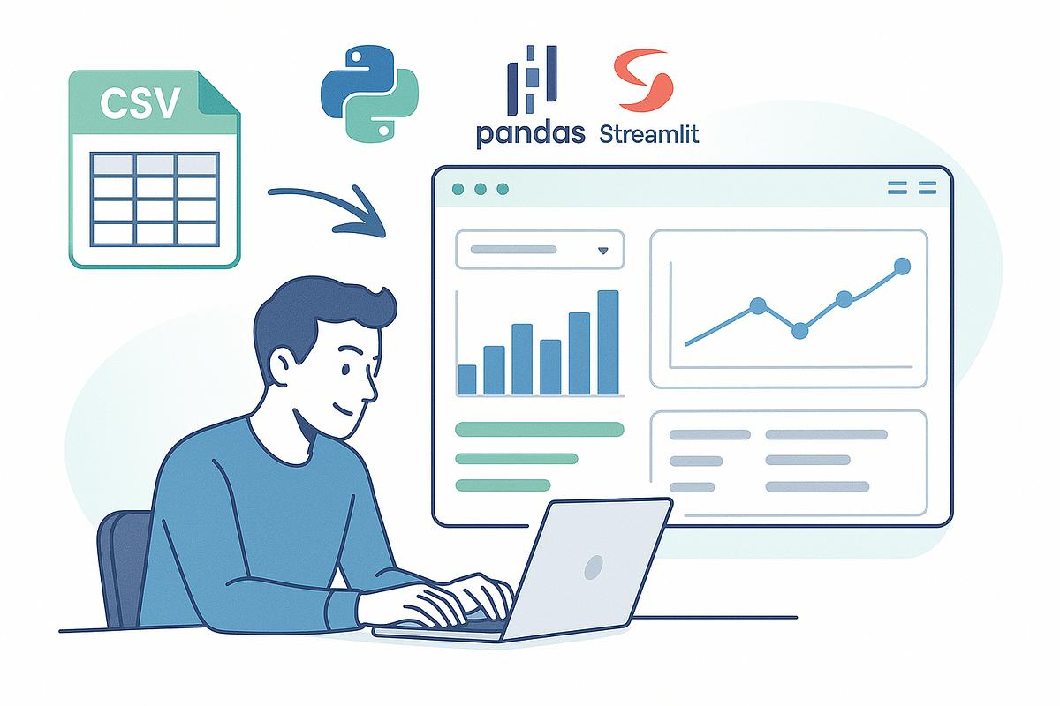

CHAPTER 4
Implementation and User Interface
4.1 High-Level Architecture
Student Dataset → Data Cleaning → Data Analysis → Visualization → Streamlit Dashboard
The architecture is organized as a simple data-analysis pipeline. The dataset is provided as input. The data is checked and prepared, analysis is performed on the prepared data, and the results are converted into visualizations. Streamlit presents the indicators and charts to the user.
4.2 Description of Each Layer
- Data input layer: receives the student dataset containing available fields such as marks, attendance, study time, absences and previous grades.
- Data preparation layer: checks the dataset and handles missing, duplicate, inconsistent or invalid values as appropriate to the actual data.
- Analysis layer: calculates summary values and examines selected relationships between variables.
- Visualization layer: creates charts and plots to communicate the analysis results.
- Dashboard layer: displays the results through a Streamlit interface.
4.3 Deployment Architecture
The project presentation identifies Streamlit as the dashboard framework but does not specify a final hosting platform or cloud deployment. The application may be run locally during development. If deployed online, the hosting platform, configuration and access method should be documented after they are finalized.
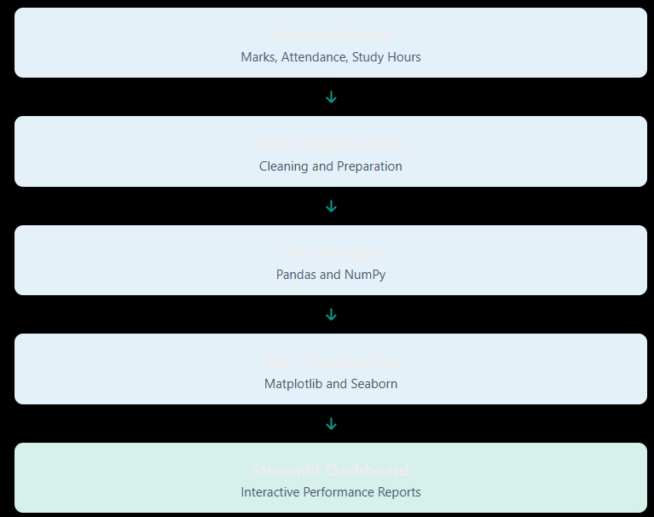

CHAPTER 5
Design :
5.1 Input Data Design
The system is designed to work with a student dataset. The project presentation identifies the following example data factors:
- Student marks or scores
- Attendance
- Study time / study hours
- Absences
- Previous grades
The exact dataset name, source, number of records, column names and file format were not provided in the presentation. Add those details here after confirming the dataset actually used.
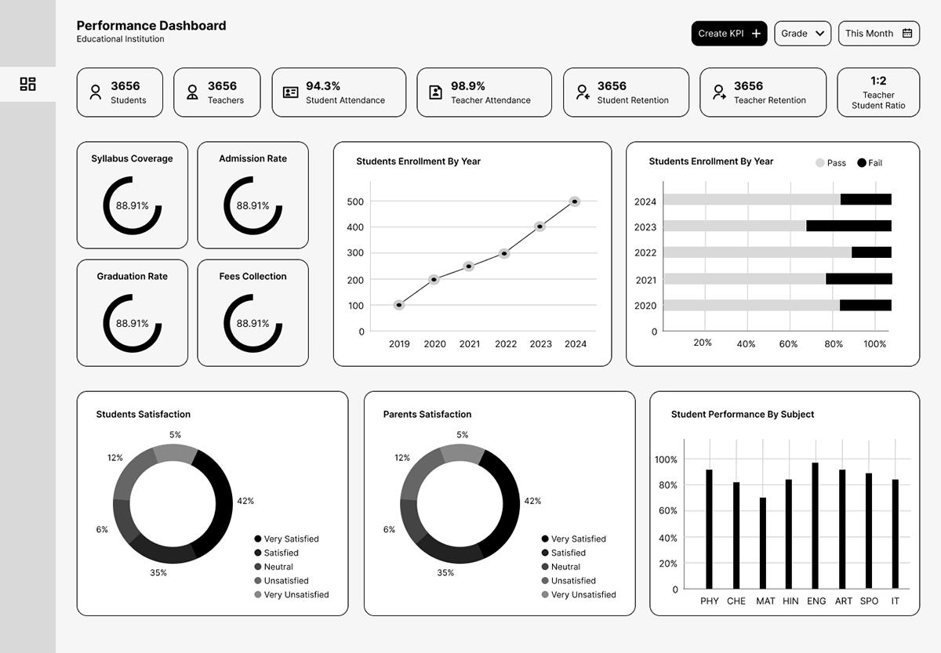
5.2 Data Processing Design
The input data is first inspected to understand its columns and values. Data cleaning is then performed based on the issues found. The prepared data is used to calculate summaries and relationships. Finally, charts and dashboard indicators are generated.
5.3 Dashboard Design
The planned dashboard can organize the results into sections such as overall performance, attendance, study hours, grade distribution and correlation analysis. The exact screen layout and screenshots should be added from the team's implemented dashboard.
5.4 Design Note
Insert actual dashboard screenshots, chart screenshots and any wireframes in this chapter. Do not use sample screenshots as evidence of completed implementation.
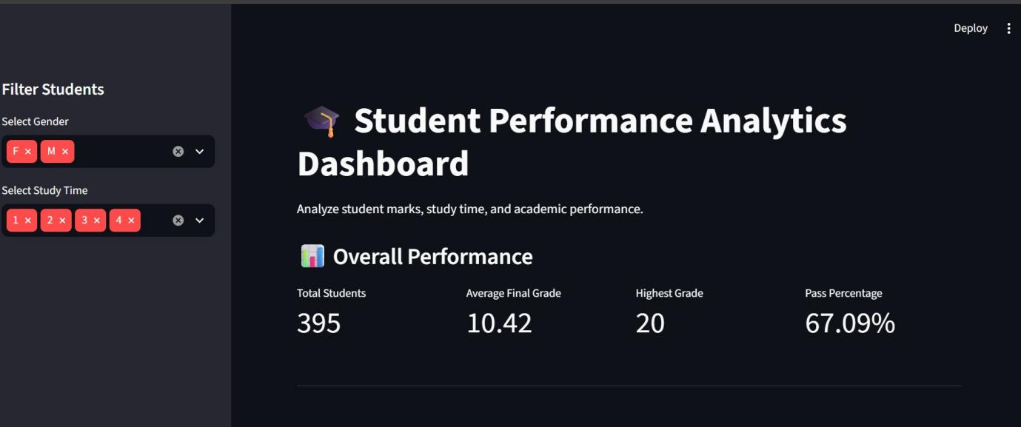

CHAPTER 6 – IMPLEMENTATION
6.1 Module-Wise Implementation
Module | Purpose
Dataset loading | Read the student data into the Python environment.
Data cleaning | Inspect and prepare the data for analysis.
Performance analysis | Calculate average marks, attendance and other selected measures.
Study-hours analysis | Examine study time in relation to student scores.
Grade distribution | Summarize how student grades or score ranges are distributed.
Correlation analysis | Examine the strength and direction of relationships between selected numerical variables.
Dashboard presentation | Display analysis outputs in Streamlit.
6.2 Data Loading and Cleaning
Pandas can be used to load a dataset into a DataFrame. The dataset should be inspected for missing values, duplicate rows, incorrect data types and invalid entries. The cleaning method should be selected according to the actual dataset; for example, missing values may be removed or handled using an appropriate replacement method.
6.3 Data Analysis
After cleaning, the system calculates descriptive summaries such as averages and counts. It can compare attendance, study time and marks and examine how grades are distributed. The exact calculations and column names should match the implemented code.
6.4 Visualization and Dashboard
Matplotlib and Seaborn can be used to create charts. Streamlit can display those charts together with summary indicators. Interactive controls, such as filters, should be described here only if they are included in the actual implementation.
6.5 Machine Learning Note
The presentation mentions machine learning as an optional addition for score prediction. It is not described as a completed core feature. If a prediction model is later implemented, document its algorithm, input features, training/testing method and evaluation metrics separately.
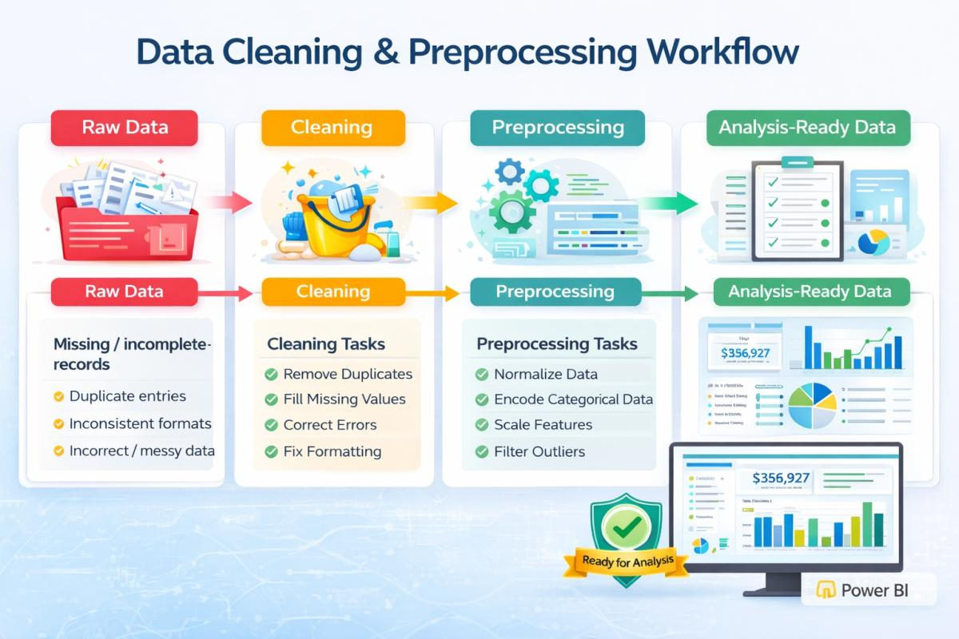
CHAPTER 7 – FEATURES
Average marks analysis
Displays the average score for the selected dataset or group.
Attendance analysis
Summarizes student attendance and supports comparison with marks.
Study-hours analysis
Shows study-time patterns and their relationship with scores.
Grade distribution
Displays the distribution of grades or score ranges.
Correlation analysis
Shows how selected numerical variables move in relation to one another.
Interactive dashboard
Presents key indicators and visualizations in one Streamlit application.
The features above are the intended outputs listed in the project presentation. Confirm each feature against the working application before describing it as implemented.
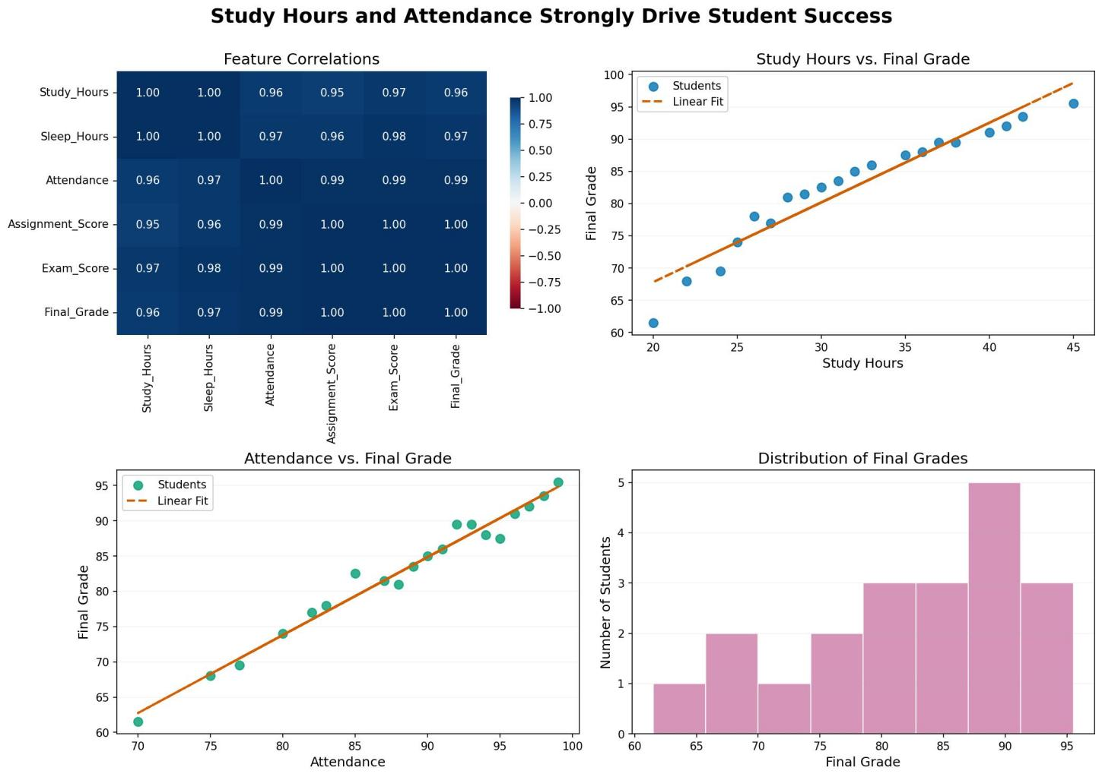

CHAPTER 8 – TESTING
8.1 Testing Approach
Testing should confirm that the dataset is loaded correctly, data preparation completes without errors, analysis values are calculated correctly, charts are generated and the Streamlit dashboard opens and displays the expected outputs.
8.2 Suggested Test Cases
Test case | Action | Expected result
Dataset loading | Load the selected student dataset. | Dataset is read and its rows and columns can be inspected.
Missing-value check | Check columns containing empty values. | Missing values are identified and handled using the selected cleaning rule.
Duplicate check | Check for repeated records. | Duplicate records are identified and handled as intended.
Summary calculation | Calculate average marks and attendance. | Displayed values match the calculations on the cleaned data.
Chart generation | Generate the selected charts. | Charts display the correct variables and data.
Correlation analysis | Calculate and visualize selected correlations. | Correlation values and heatmap correspond to the cleaned data.
Dashboard launch | Run the Streamlit application. | Dashboard opens and displays available indicators and charts.
8.3 Testing Tools
Testing may be performed using the Python environment, the selected code editor or notebook, and a web browser for checking the Streamlit interface. Record the actual tools and test outcomes used by the team.
8.4 Test Results
[To be completed by the team: record Pass/Fail for each test case, actual output, date tested and any issue found. The project presentation does not provide measured test results.]

CHAPTER 9 – DEPLOYMENT
9.1 Local Execution
A typical local execution process is to install Python, create or activate the project environment, install the required libraries, place the dataset in the configured project location and start the Streamlit application. The exact command and file name must match the team's project.
Example command (replace app.py with the actual Streamlit entry file):
streamlit run app.py
9.2 Environment Configuration
The environment should contain compatible versions of Python, Pandas, NumPy, Matplotlib, Seaborn and Streamlit. Record the versions used in the final submission if required by the course.
9.3 Hosting
The presentation does not specify a public hosting provider. If the application is hosted online, add the platform name, deployment steps, URL and configuration details. Otherwise, state that the application is demonstrated locally.

CHAPTER 10 – CHALLENGES AND LIMITATIONS
10.1 Possible Development Challenges
- Handling missing or inconsistent values in the dataset.
- Choosing suitable charts for different types of data.
- Interpreting relationships without assuming that correlation proves causation.
- Keeping the dashboard clear and easy to use.
10.2 Solutions / Handling Methods
The data should be inspected before analysis, cleaning rules should be applied consistently, and charts should be selected according to the variables being compared. Results should be interpreted carefully and explained in simple terms.
10.3 Current Limitations
- The quality of the insights depends on the accuracy and completeness of the input dataset.
- Correlation analysis shows association, not proof of cause and effect.
- The presentation does not specify a deployed online version.
- Machine-learning-based score prediction is optional and should not be claimed unless implemented.
- The project does not describe a student login system or role-based access.

CHAPTER 11 – FUTURE ENHANCEMENTS
- Add a machine-learning model to estimate student scores, after collecting suitable data and evaluating the model.
- Add filters for class, semester or other available student groups.
- Include additional visualizations and more detailed comparisons.
- Add early-warning indicators to help educators review students who may need support.
- Deploy the dashboard on a suitable hosting platform for wider access, if required.
- Improve data privacy and access controls when handling identifiable student records.
These are possible future improvements and are not presented as completed features.

